**How to run the Sorting CSV File Assignment.**

Step 1.

Import the Project from Git Repository to the Eclipse IDE.

Step 2.

Make sure the two CSV files are available in ClassPath. Where all .class file available.

Step 3.

Now In the Eclipse IDE click on Run -> RunConfigurations option.

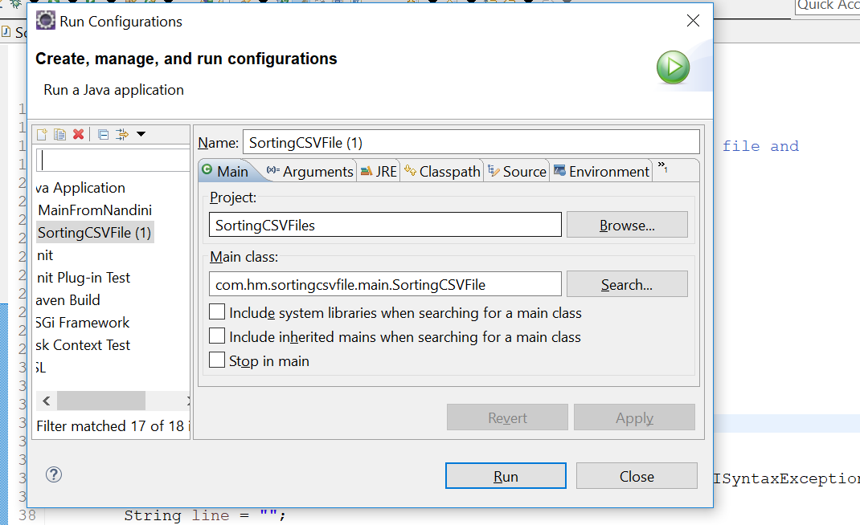

Step4:

Click on Arguments and insert the required parameter list.

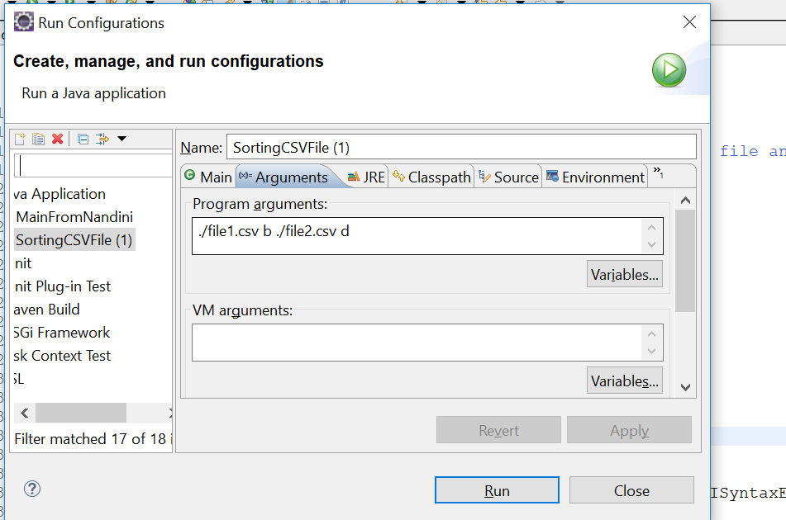

OutPut:

